**Thammasak Booncherd (1945-)**

Thammasak Booncherd was a Thai artist known for his politically motivated paintings and posters. Born to a family of farmers in Nakhon Srithammarat, a Southern province of Thailand. Thammasak was brought up in an atmosphere of political awareness. He entered Silpakorn University in Bangkok during a period of political turmoil in the 1970s. At this time, university students and intellectuals were greatly involved in political and social movements, especially towards the disposition of Communism. This generated in Thammasak great interest in social and political issues despite the fact that his art students continued to favour abstract art.

During 1975-6, Thammasak had joined the teaching staff of Korat Technical College in Nakhon Rachasima province in the Northeast of Thailand. Here he had an opportunity to meet a group of teachers and artists whose works reflected strong social and political views. From 1975 onwards he began to create his own works focused on political and social commentary. He later joined Dhamma Group under the leadership of Pratuang Emcharoen. The 3rd Dhamma Group’s exhibition entitled *Silapa Khong Prachachon* (The Art of the People) opened in the evening of October 5, 1976, just a few hours before the massacre of university students protesting at Thammasat University on October 6th.

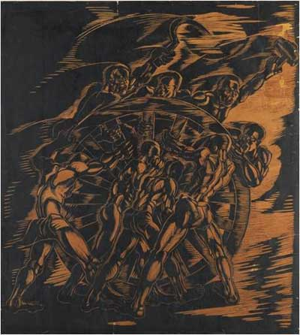

Thammasak Booncherd, *Kong Lor Prawatthisart* (Wheels of History), 1993, woodcut print, collection of Sermkhun Kunawong.

After October 6th 1976, six pieces of the Dhamma Group’s exhibited works were burnt and destroyed by other artists because of their message of resistance towards the military regime and American imperialism. The destruction of these works led Thammasak and others to adopt Communist politics, which were against the law at the time. After the incident, like many of his student contemporaries and political activists, Thammasak decided to escape from the military crackdown and remained in the forest with student movement forces for three months. In 1978, when the political unrest subsided, Thammasak returned to Bangkok. He began a new job as political cartoonist in *Arthit Raiwan*, a daily newspaper.

During the 1980s, Thammasak explored various art mediums and movements, including Conceptual Art, Environmental Art, Performance, Installation and even Abstract Art. The political statement directly expressed in his earlier paintings were subtly voiced in his later works.

**List of Works**

Rama 9 Art Museum. *Thammasak Booncherd*, [online], Available online: <http://www.rama9art.org/artisan/artdb/artists/home.php?p=profiles&name=Thammasak%20Booncherd> (This website includes images held in the Rama Art Collection and brief biographical information about the artist)

**Biography and Further Reading**

Apinan Poshyananda. (1992) *Modern Art in Thailand: Nineteenth and Twentieth Centuries*, Singapore: Oxford University Press.

Thammasak Booncherd (1992) *Summer ’92: Drawing, Water Colour & Oil Paintings* (Exhibition Catalogue), Bangkok: River City.

Thammasak Booncherd (1999) *Thammasak Booncherd: Three Dimension Work: Sculpture, Mix Media, Assemblage* (Exhibition Catalogue), Bangkok: The National Gallery.

Vichoke Mukdamanee, et. al. (2004), *Six Decades of Contemporary Art in Thailand, 1943-2003* (Exhibition Catalogue), Bangkok: Art Centre, Silpakorn University.